**international communications**

**30-day media report – Research article**

**Original paper:** Towards Sustainable Cities: Studying Evaluation Index of Water Environment Carrying Capacity

**Journal:** Water Resources Management

**Authors:** Jiaxi Chen, Xiaonan Tang

**Date Published:** 31 October 2023

**DOI:** <https://doi.org/10.1007/s11269-023-03635-5>

**Title of press release:** New methods for improving water management to develop sustainable cities

**Date Published:** 1 December

**URL:** <https://www.xjtlu.edu.cn/en/news/2023/12/new-methods-for-improving-water-management-to-develop-sustainable-cities>

**Total number of unique readers of the media outlets that picked up the article per month:**

**8,101,068**

**Number of views of media release per site where it was uploaded:**

|  |  |  |
| --- | --- | --- |
| Website | Views | Social media shares |
| ScienceX | 3510 | 17 |
| EurekAlert | 938 | n/a |
| Alpha Galileo | 152 (journalists) | n/a |

**Number of media outlets that picked up the media release (excluding Chinese outlets):**

12

**Languages the article has been translated into (not including Chinese):**

Indonesian, Italian, Korean

**Altmetric score**

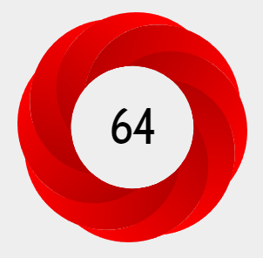

**In the top 3% of all research outputs scored by Altmetric.**

The Altmetric Attention Score for a research output provides an indicator of the amount of attention that it has received. The score is derived from an automated algorithm, and represents a weighted count of the amount of attention we've picked up for a research output.

Thanks for your support and we look forward to working with you again!

The International Communications Team